Grooming/Bathing Client Report Card
Client’s Name_____________________________________________________________Phone #__________________
Pet’s Name______________Breed_______________Color_____________________Sex_____Age_______ Weight_____
All pets need to be up-to-date on vaccinations. Proof of vaccinations needs to be provided.
If not up-to-date, LV-SM Vet hospital can vaccinate at shot clinic price. (Separate from grooming charges.)
_____Pet is up-to date _____Needs Vaccines (Dogs-Da2pl, Bordetella, Rabies. Cats-Prc-feluk, Rabies)
Does your pet have any medical issues we need to be aware of? (Examples: Arthritis, Allergies.)
No_______ Yes (Please Explain) ________________________________________________________________
When was the last time your pet was groomed? ________
Does your pet have any trouble areas? (Example: Doesn't like nails trimmed)
__________________________________________________________________________________________________
What services would you like your pet to receive today?
______Bath _____Light Brush (15 minute or less) _______Nail Trim ______Sanitary Clip _____Face/Feet/ Sanitary Clip
_______Hair Cut (Please, specify what kind of hair cut. If not specified, it is left to the groomer’s discretion.) _____________________________________________________________________________________________________________________________________________________________________________________________________________
_______Heavy duty brushing/de-matting is charged on an hourly bases. If you think your pet needs de-matting, discuss with groomer beforehand.
Medicated or De-shedding shampoo _______$5.00 Sm/Med ________$10 Large
If extra help is needed to assist with any of the above actions, there may be additional charges. ______
Would you like a______ bandana _____bows _____ cologne_____? (No extra Charge)
If your pet has mats that cannot be humanely brushed out, we will clip them out or if it is in your pets best interest we will clip him/her short all over.
Signature_______________________________________ Date___________
Groomer’s Hair Cut Notes
Body
Legs
Face/Head
Other
Charges
Base Charge
Other
Tax
Total
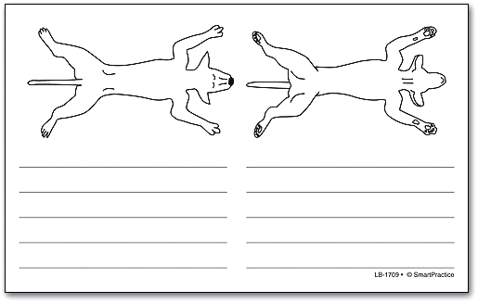

Grooming/Bathing Client Report Card
Client’s Name_____________________________________________________________Phone #__________________
Pet’s Name______________Breed_______________Color_____________________Sex_____Age_______ Weight_____

Your pet was good for the following:
____Bath ____Nails ____Ears ____Driers ____Brushing ___Face handled
____Clippers ____Feet/legs handled ____Being in cage

Needs some work with on the following:
____Bath ____Nails ____Ears ____Driers ____Brushing ___Face handled
____Clippers ____Feet/legs handled ____Being in cage

We noticed these things today:
____Lumps/bumps ____Red/ sore/ waxy ears ____Flaky skin ____Dry skin ____Oily skin ____Matting
____Needs Dental ______Possible Allergies _______Needs to see Vet _______OTHER
Comments/Reccomendations:_____________________________________________________________________________________________________________________________________________________________________________________________________________________________________________________________________________________________________________________________________________________________________________________________________________________________________________________________________________________________________________________________________________
We recommend _________to be bathed/groomed every________and brushed with a_____________every________.
Needs another nail trim in ______weeks.
Groomer’s Hair Cut Notes
Body
Legs
Face/Head
Other
Charges
Base Charge
Other
Tax
Total

